1. please kindly check the wire connection details as below, you can also find it in your manual.

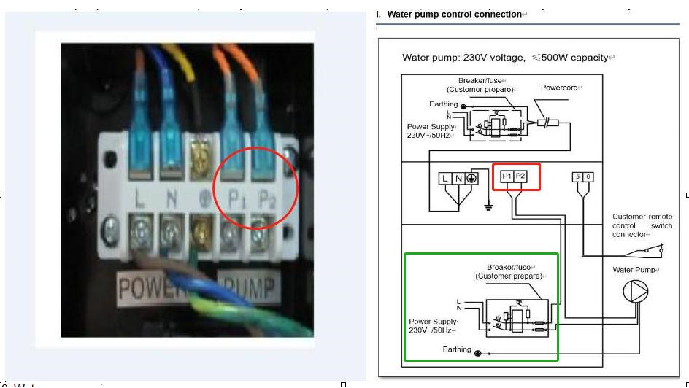

1. what's the water pump running way:

0：Continuation mode (default setting): When the heat pump is turned on, the water pump will be turned on at the same time. When the heat pump is off, the water pump will be off after 60s.When the set temperature is reached, the heat pump will automatically standby, water pump will continue running.

1：Water temp control: When the heat pump is turned on, the water pump will be turned on 60 seconds before the compressor is turned on. When the heat pump is turned off, the water pump will be off after 60s. When the set temperature is reached, the heat pump will automatically standby, water pump will be off after 60s.

2：time/water temp control: When the heat pump is turned on, the water pump will be running 3 mins first to test the water temperature, if more than 1 degree different, the compressor will be turned on. When the heat pump is turned off, the water pump will be off after 60s. When the set temperature is reached, the heat pump will automatically standby, water pump will be off 60min, and then will turned on and running 3 mins to test the water temperature and see whether turned on the compressor or not and keep repeat this cycle.

1. If you want to change to 1 or 2 mode, please kindly check below controller setting：

1. Parameters Checking

1.1 Press“”and “” together for 5 seconds, after sound "Di", enter “parameter checking” status, parameter code NO."P0” and default parameter value “2” will display.

1.2 Press “” Key and “” Key to check the parameters.

1.3 Press “” key to exit "parameter checking" status.

2. Modify parameters

2.1 In "parameter checking" status, press “” to enter "parameter setting" status.

2.2 In "parameter setting" state, press “” and “” to change the parameters value

2.3. Press “”to confirm and return to the previous status; Or press “” key to quit and return to the previous status.

3 Parameter Table

|  |  |  |  |  |  |
| --- | --- | --- | --- | --- | --- |
| NO. | Content | Adjust range | Step length | Default | Remark |
| P0 | Water pump running way | 0: Continuation  1: Water temp control  2:time/water temp control | 1 | 0 | Can change  (P0-P5) |
| P1 | Time setting ( only available when the water pump running way is set to “2” | 10 ~ 120 min | 5 min | 60 min |